Heart Disease Analysis

Heart Disease Risk Analysis & Interactive Web Visualization System

PROJECT DESCRIPTION

- System Overview : A comprehensive data analytics platform that seamlessly integrates a structured SQL database system, Tableau's powerful business intelligence engine, and a lightweight Flask web application to analyze and visualize heart disease data.
- Problem Domain: Heart disease remains a leading cause of global mortality. Analyzing large-scale health data requires advanced tools for extracting insights to aid in preventive care and awareness.
- Core Technology Used: SQL (Data storage & cleaning), Tableau (Data Visualization & Storyboarding), Python/Flask (Web Framework), HTML/CSS (Responsive GUI).
- Key Capabilities: Systematic data collection, automated SQL data preparation, dynamic Tableau dashboard creation with calculated fields, and responsive web integration tracking Key Performance Indicators (KPIs).
- Target Users: Healthcare professionals, policymakers, and individual patients.
- Real-world Relevance: Transforms raw clinical data into meaningful dashboards that highlight risk factors, uncover hidden trends, and support better decision-making for preventive medical care.

APPLICATION SCENARIOS / USE CASES

- Healthcare Provider Usage: Doctors use the dashboard for real-time monitoring and analysis of patient comorbidities, specifically analyzing people suffering from diabetes and stroke alongside heart disease.
- Public Health/Policy Usage: Policymakers track key performance metrics and demographic trends (Race-wise and Age-wise Heart Disease) to communicate results and allocate resources.
- End-user usage: Individuals access the responsive web dashboard on their mobile phones to explore complex data intuitively and understand how their personal physical activity or BMI compares to heart disease trends.

TECHNICAL ARCHITECTURE OVERVIEW
• Data / Request Flow: 1. Data is collected and stored in a structured SQL database. 2. SQL operations clean and filter the data. 3. A secure, reliable connection is established between the database and Tableau. 4. Tableau handles visualization and dashboard creation. 5. The Flask web app embeds the published Tableau dashboards, delivering them to the user's browser.
• Frontend layer: HTML, CSS, JavaScript (Tableau Embed API) ensuring responsive dashboards that adapt to different screen sizes.
• Backend layer: Python with Flask framework handling web routing.

• Database layer: Structured SQL database handling data transformation and null-value handling.
• External APIs / Services: Tableau Server / Tableau Public for hosting the dashboards.

PREREQUISITES
• Software Requirements: Tableau Desktop/Public, SQL Database Server (e.g., MySQL, PostgreSQL), Web Browser.
• Development tools: Python 3.9+, Git.
• IDE: VS Code, PyCharm, or Jupyter Notebook.
• Libraries / Frameworks / Dependencies: flask, pandas, sqlal , mysql-connector-python

PRIOR KNOWLEDGE REQUIRED

Concepts required before implementation:

- Programming language knowledge: Python, SQL.Framework basics
- Framework basics: Flask web routing.Networking / Cloud concept
- Database fundamentals: SQL querying, data normalization, database connections.
- Analytics/BI: Tableau calculated fields, storyboarding, and dashboard publishing.

PROJECT OBJECTIVES
• Technical objectives: Build a seamless data pipeline from SQL storage to Tableau visualization, embedded in a Flask GUI.
• Performance objectives: Ensure the dashboard is responsive across desktop, tablet, and phone screens with clear fonts and simplified visuals.
• Deployment objectives: Publish dashboards to track and monitor key performance metrics and embed them via Flask for accessible sharing.

SYSTEM WORKFLOW

Step-by-step execution flow:

- Data Collection: Gathering and measuring information on variables of interest (BMI, Smoking, Stroke, etc.) in a systematic fashion.
- Database Storage & SQL Operations: Storing the collected dataset in a structured database. Using SQL to clean, filter, transform, and prepare data.
- Tableau Connection: Establishing a secure and reliable connection between the DB and Tableau for dynamic data access.
- Data Transformation (Tableau): Cleaning and organizing connected data, creating calculated fields, and handling null values.

- Data Visualization & Storyboarding: Creating graphical representations (charts, graphs, maps) to make complex datasets intuitive.
- Publishing & Flask Integration: Publishing the storyboard to communicate results, and embedding it into a Flask web app for real-time access.

MILESTONE 1: REQUIREMENT ANALYSIS & SYSTEM DESIGN

• Problem Definition: Complex health data must be made accessible to non-technical users to generate insights on heart disease.
• Functional Requirements: Data engineering via SQL, interactive dashboarding, and Flask web deployment.
• Non-Functional Requirements: Responsive design, real-time data access, and secure database connections.
• Technology Stack Selection Justification: Tableau is chosen for its industry-leading visualization capabilities; Flask is chosen as a lightweight framework to make the analysis accessible directly in a browser.

MILESTONE 2: ENVIRONMENT SETUP & INITIAL CONFIGURATION

• Development Environment Setup: Set up Python virtual environment and local SQL server.
• Dependency Installation: pip install flask pandas
• Configuration Setup: Established ODBC connection drivers between the SQL server and Tableau Desktop. Set up the templates and static folders for Flask

MILESTONE 3: CORE SYSTEM DEVELOPMENT

  - Feature 1 – Data Engineering (SQL):

    - Description: Executed SQL operations to clean the Heart_new2.csv data. Filtered invalid entries and transformed categorical strings into structured formats for seamless Tableau integration
  - Feature 2 – Tableau Storyboarding (Visual Analysis):

- Description: Developed a visual representation of the data analysis process broken down into the following specific scenes:
- Gender wise Heart Disease
- Age wise Heart Disease
- People Suffering from Diabetic and Stroke
- Impact of Smoking and alcohol drinking on heart disease
- Other Diseases vs Stroke
- Race wise Heart disease
- General Health vs Heart Disease
- Physical activity vs heart disease
- Age and BMI vs Heart disease.
- People got stroke suffering from Diabetes and Heart disease

  - Feature 3 –Flask Web Integration:

    - Description: Developed a GUI using HTML/CSS and embedded the Tableau Javascript API to render the published storyboards inside the web application.

- MILESTONE 4: INTEGRATION & OPTIMIZATION
  - Component Integration: Connected the published Tableau Story URL to the Flask HTML templates using <tableau-viz> tags.
  - Performance Optimization: Ensured flexible layouts. Simplified visuals for small screens and tested on multiple devices to ensure a highly responsive dashboard.
  - Error Handling & Validation: Handled null values during the Tableau data preparation phase to prevent chart rendering errors.

MILESTONE 5: TESTING & VALIDATION

Test Case ID | Input | Expected Output | Status
TC-01 | Web server start command (python app.py) | Flask app launches on localhost:5000 | Pass
TC-02 | Navigate to "Comorbidities" tab | Story scene "People got stroke suffering from Diabetes and Heart disease" loads | Pass
TC-03 | View dashboard on mobile device emulator | Dashboard adapts to screen size, keeping fonts and colors clear | Pass
TC-04 | Filter "Age wise Heart Disease" by Male gender | Chart dynamically updates via Tableau server | Pass

DEPLOYMENT
  - Deployment Architecture: Cloud-hosted web application with external BI API integration.Hosting Platform
  - Hosting Platform: Tableau Public (Dashboards) + Python Web Host
  - Deployment Steps: Publish storyboard to Tableau Server -> Copy embed credentials -> Update Flask templates -> Push to web host.

PROJECT STRUCTURE

Present clean folder structure:

project_root/
│
├── src/
│ └── data_prep.sql # SQL operations to clean/filter data
├── static/
│ ├── css/style.css # Responsive dashboard layouts
│ └── js/embed.js # Tableau embedding scripts
├── templates/
│ ├── layout.html # Base GUI format
│ └── index.html # Main dashboard view
├── app.py # Flask routing application
└── requirements.txt # Dependencies

RESULTS

- System Output: An organized, easy-to-read web GUI that displays heart disease data and tracks KPIs.
- Performance Evaluation: The system successfully adapts to desktop, tablet, and phone screens. Complex datasets are made intuitive, allowing users to quickly identify patterns, trends, and outliers regarding factors like BMI, Smoking, and Diabetes.

- Screenshots

Dashboard 1 :-
Dashboard 1 public Link :-
https://public.tableau.com/views/Heart_Analysis1/Dashboard13?:language=en-US&publish=yes&:sid=&:redirect=auth&:display_count=n&:origin=viz_share_link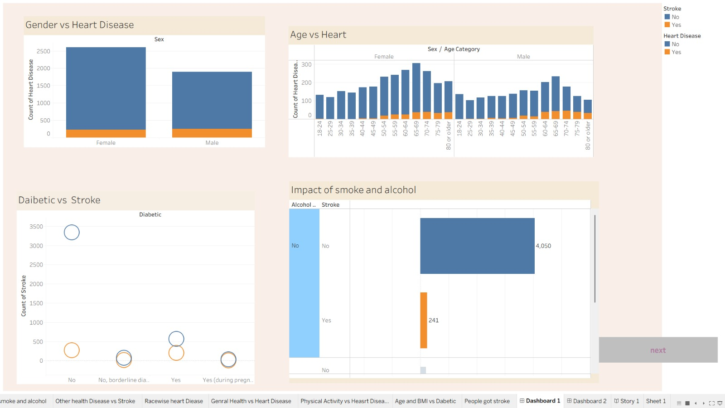

Dashboard 2 :-
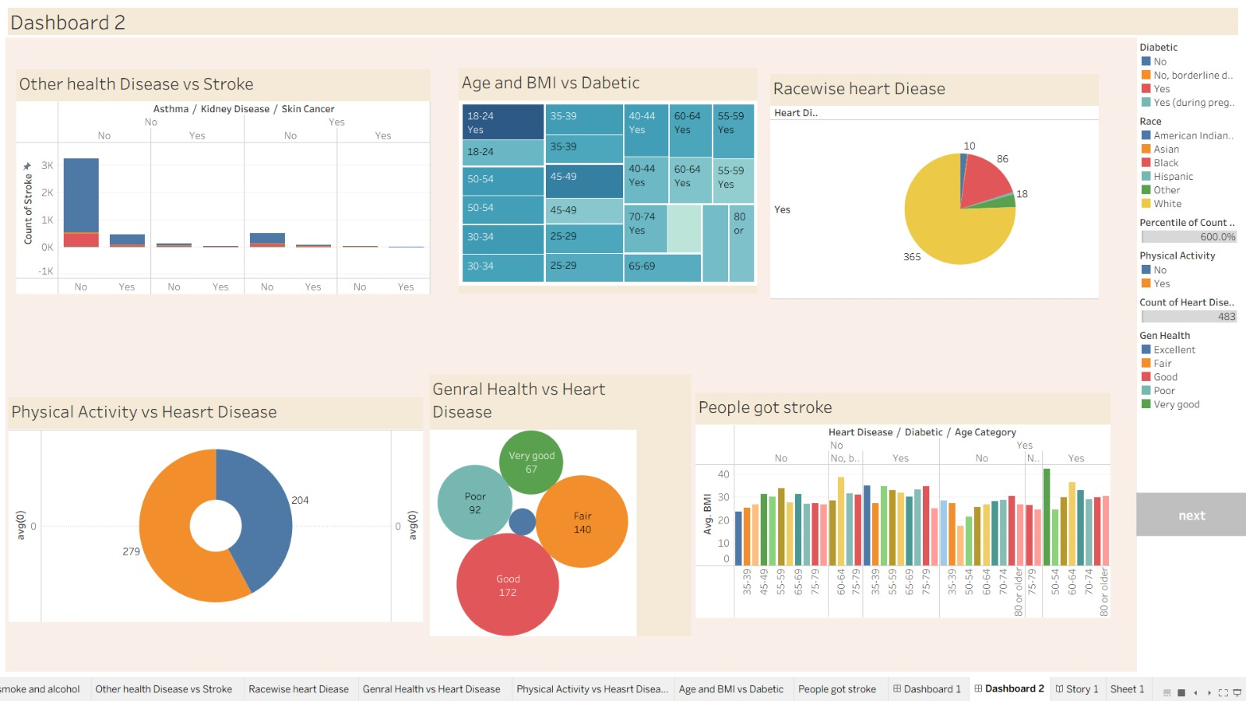
Dashboard 2 public Link :- https://public.tableau.com/views/Heart_Analysis2/Dashboard23?:language=en-US&publish=yes&:sid=&:redirect=auth&:display_count=n&:origin=viz_share_link

ADVANTAGES & LIMITATIONS

- Advantages: Extremely accessible; allows stakeholders to make better decisions without needing Tableau software installed. Real-time dynamic filtering.
- Automation: Implementing scheduled data refreshes using Tableau Server to pull new patient records from the SQL database automatically

CONCLUSION

- The project successfully established a systematic pipeline for health data analysis. By leveraging SQL for data preparation, Tableau for storyboarding complex correlations (such as Age, BMI, and lifestyle habits), and Flask for responsive web deployment, the system effectively communicates critical performance metrics and medical insights to a diverse set of users.

APPENDIX

- Source Code

HTML CODE :-

<!DOCTYPE html>
<html lang="en">

<head>
<meta charset="UTF-8">
<meta name="viewport" content="width=device-width, initial-scale=1.0">
<title>Heart Analysis Analytics Portal</title>
<link href="https://cdn.jsdelivr.net/npm/bootstrap@5.3.0/dist/css/bootstrap.min.css" rel="stylesheet">
<link rel="stylesheet" href="https://cdn.jsdelivr.net/npm/bootstrap-icons@1.10.5/font/bootstrap-icons.css">
<style>
body {
font-family: 'Segoe UI', Tahoma, Geneva, Verdana, sans-serif;
background-color: #f4f7f6;
overflow-x: hidden;
}

.sidebar {
height: 100vh;
background-color: #2c3e50;
color: white;
padding-top: 20px;
position: fixed;
width: 250px;
}

.sidebar a {
color: #adb5bd;
text-decoration: none;
padding: 15px 20px;
display: block;
font-size: 1.1rem;
transition: 0.3s;
cursor: pointer;
}

.sidebar a:hover,
.sidebar a.active {
background-color: #34495e;
color: white;
border-left: 4px solid #3498db;
}

.main-content {
margin-left: 250px;
padding: 30px;
}

.dashboard-wrapper {
background: white;
border-radius: 8px;
padding: 15px;
box-shadow: 0 4px 12px rgba(0, 0, 0, 0.05);
min-height: 850px;
display: flex;
justify-content: center; /* Centers the story if it has fixed width */
}

.view-section {
display: none;
width: 100%;
}

.view-section.active {
display: block;
}
</style>
</head>

<body>

<div class="sidebar">
<h4 class="text-center mb-4 text-light">Analytics Portal</h4>
<a onclick="showSection('dashboard1')" id="nav-dashboard1" class="active">
<i class="bi bi-heart-pulse-fill me-2"></i> Heart Analysis 1
</a>
<a onclick="showSection('dashboard2')" id="nav-dashboard2">
<i class="bi bi-activity me-2"></i> Heart Analysis 2
</a>
<a onclick="showSection('story')" id="nav-story">
<i class="bi bi-book me-2"></i> Data Story
</a>
<a href="#"><i class="bi bi-file-earmark-text me-2"></i> Project Report</a>
<a href="#"><i class="bi bi-gear me-2"></i> Settings</a>
</div>

<div class="main-content">
<div class="d-flex justify-content-between align-items-center mb-4">
<div>
<h2 id="main-title">Heart Analysis Dashboard 1</h2>
<p class="text-muted" id="main-subtitle">AI-driven medical insights and health optimization.</p>
</div>
<div>
<button class="btn btn-primary"><i class="bi bi-download me-1"></i> Export Data</button>
</div>
</div>

<div class="dashboard-wrapper">
<div id="dashboard1" class="view-section active">
<div class='tableauPlaceholder' id='viz1772880805228' style='position: relative'>
<noscript><a href='#'><img alt='Dashboard 1 ' src='https:&#47;&#47;public.tableau.com&#47;static&#47;images&#47;He&#47;Heart_Analysis1&#47;Dashboard13&#47;1_rss.png' style='border: none' /></a></noscript>
<object class='tableauViz' style='display:none;'>
<param name='host_url' value='https%3A%2F%2Fpublic.tableau.com%2F' />
<param name='embed_code_version' value='3' />
<param name='site_root' value='' />
<param name='name' value='Heart_Analysis1&#47;Dashboard13' />
<param name='tabs' value='no' />
<param name='toolbar' value='yes' />
<param name='static_image' value='https:&#47;&#47;public.tableau.com&#47;static&#47;images&#47;He&#47;Heart_Analysis1&#47;Dashboard13&#47;1.png' />
<param name='animate_transition' value='yes' />
<param name='display_static_image' value='yes' />
<param name='display_spinner' value='yes' />
<param name='display_overlay' value='yes' />
<param name='display_count' value='yes' />
<param name='language' value='en-US' />
<param name='filter' value='publish=yes' />
</object>
</div>
</div>

<div id="dashboard2" class="view-section">
<div class='tableauPlaceholder' id='viz1772882016708' style='position: relative'>
<noscript><a href='#'><img alt='Dashboard 2 ' src='https:&#47;&#47;public.tableau.com&#47;static&#47;images&#47;He&#47;Heart_Analysis2&#47;Dashboard23&#47;1_rss.png' style='border: none' /></a></noscript>
<object class='tableauViz' style='display:none;'>
<param name='host_url' value='https%3A%2F%2Fpublic.tableau.com%2F' />
<param name='embed_code_version' value='3' />
<param name='site_root' value='' />
<param name='name' value='Heart_Analysis2&#47;Dashboard23' />
<param name='tabs' value='no' />
<param name='toolbar' value='yes' />
<param name='static_image' value='https:&#47;&#47;public.tableau.com&#47;static&#47;images&#47;He&#47;Heart_Analysis2&#47;Dashboard23&#47;1.png' />
<param name='animate_transition' value='yes' />
<param name='display_static_image' value='yes' />
<param name='display_spinner' value='yes' />
<param name='display_overlay' value='yes' />
<param name='display_count' value='yes' />
<param name='language' value='en-US' />
<param name='filter' value='publish=yes' />
</object>
</div>
</div>

<div id="story" class="view-section">
<div class='tableauPlaceholder' id='viz1772882952634' style='position: relative'>
<noscript><a href='#'><img alt='HEART DISEASE STORY ' src='https:&#47;&#47;public.tableau.com&#47;static&#47;images&#47;Bo&#47;Book3_17728828725390&#47;Story1&#47;1_rss.png' style='border: none' /></a></noscript>
<object class='tableauViz' style='display:none;'>
<param name='host_url' value='https%3A%2F%2Fpublic.tableau.com%2F' />
<param name='embed_code_version' value='3' />
<param name='site_root' value='' />
<param name='name' value='Book3_17728828725390&#47;Story1' />
<param name='tabs' value='no' />
<param name='toolbar' value='yes' />
<param name='static_image' value='https:&#47;&#47;public.tableau.com&#47;static&#47;images&#47;Bo&#47;Book3_17728828725390&#47;Story1&#47;1.png' />
<param name='animate_transition' value='yes' />
<param name='display_static_image' value='yes' />
<param name='display_spinner' value='yes' />
<param name='display_overlay' value='yes' />
<param name='display_count' value='yes' />
<param name='language' value='en-US' />
<param name='filter' value='publish=yes' />
</object>
</div>
</div>
</div>
</div>

<script type='text/javascript'>
// Initialize Dashboards and Story
const initViz = () => {
// Dashboard 1
var div1 = document.getElementById('viz1772880805228');
var viz1 = div1.getElementsByTagName('object')[0];
viz1.style.width = '100%';
viz1.style.height = (div1.offsetWidth > 800) ? (div1.offsetWidth * 0.75) + 'px' : '1377px';

// Dashboard 2
var div2 = document.getElementById('viz1772882016708');
var viz2 = div2.getElementsByTagName('object')[0];
viz2.style.width = '100%';
viz2.style.height = (div2.offsetWidth > 800) ? (div2.offsetWidth * 0.75) + 'px' : '2177px';

// Story
var divStory = document.getElementById('viz1772882952634');
var vizStory = divStory.getElementsByTagName('object')[0];
// Using your provided fixed dimensions for the story
vizStory.style.width = '100%';
vizStory.style.maxWidth = '1016px';
vizStory.style.height = '991px';

// Load Script
var scriptElement = document.createElement('script');
scriptElement.src = 'https://public.tableau.com/javascripts/api/viz_v1.js';
viz1.parentNode.insertBefore(scriptElement, viz1);
};

initViz();
</script>

<script>
function showSection(sectionId) {
document.querySelectorAll('.view-section').forEach(section => section.classList.remove('active'));
document.getElementById(sectionId).classList.add('active');

document.querySelectorAll('.sidebar a').forEach(link => link.classList.remove('active'));
document.getElementById('nav-' + sectionId).classList.add('active');

const title = document.getElementById('main-title');
const sub = document.getElementById('main-subtitle');

if (sectionId === 'dashboard1') {
title.innerText = 'Heart Analysis Dashboard 1';
sub.innerText = 'Patient demographics and initial risk factor assessment.';
} else if (sectionId === 'dashboard2') {
title.innerText = 'Heart Analysis Dashboard 2';
sub.innerText = 'Deep dive into clinical markers and diagnostic results.';
} else {
title.innerText = 'Heart Disease Story';
sub.innerText = 'A guided narrative through the heart health data findings.';
}
}
</script>

<script src="https://cdn.jsdelivr.net/npm/bootstrap@5.3.0/dist/js/bootstrap.bundle.min.js"></script>
</body>

</html>

VS CODE Python

from flask import Flask, render_template
app = Flask(__name__)
@app.route('/')
def home():
# This renders the HTML page containing your dashboard
return render_template('index.html')
if __name__ == '__main__':
# Runs the server in debug mode so you can see changes instantly
app.run(debug=True, port=5000)

- Dataset Details
https://drive.google.com/file/d/190Qmq27LeZZ_nWricP3Obl7ys_5otEsp/view

- GitHub Repository Link

- Live Demo Link

